**DAILY ONLINE ACTIVITIES SUMMARY**

|  |  |  |  |  |  |  |  |
| --- | --- | --- | --- | --- | --- | --- | --- |
| **Date:** | | **28/05/2020** | | | | | |
| **Name of the Faculty** | | **Sayeesh** | | | | | |
| **No. of Students Allotted for monitoring** | | | | | **19** | | |
| **Progress** | | | | | **16** | | |
| **Whether collected report from all the allotted students** | | | | | **Yes** | | |
| **Online Test Summary** | | | | | | | |
| **Subject** | **Aadalitha Kannada** | | | | | | |
| **Semester** | **4th Semester**  **A & B** | | | **Duration** | | **5 Minutes** | |
| **No. of students Taken** | | | **83** | **Passing %** | | **95%** | |
| **Certification Course Summary** | | | | | | | |
| **Course** | | Diploma in HTML5, CSS3 and JavaScript (All Assessment Completed) | | | | | |
| **Certificate Provider** | | **Alison** | | | **Duration** | | **15 Hours** |
| **Coding Challenges** | | | | | | | |
| **Problem Statement: 1. write jsp code to display today’s date and time using expression tag**  **2. write jsp script to determine how many times the visitor has loaded the page** | | | | | | | |
| **Status: 31 students executed.** | | | | | | | |
| **Uploaded the report in Github** | | | | | **Yes** | | |
| **If yes Repository name** | | | | | <https://github.com/orgs/alvas-education-foundation/teams/sayeesh> | | |
| **Uploaded the report in slack** | | | | | **Yes** | | |

Online Test Details: (Attach the snapshot and briefly write the report for the same)

Certification Course Details: (Attach the snapshot and briefly write the report for the same)

Coding Challenges Details: (Attach the snapshot and briefly write the report for the same)

**Certification Course Summary**

# Completed the course in Diploma in HTML5, CSS3 and JavaScript

# Successfully completed All Assessment

# 

**Attended Skycampus Digital Knowledge Series - Season 7**

*Hosted by ICT Academy, G. Saravanan (Moderator), Dr. Madhusudan Singh* (Morning 11 to 12)

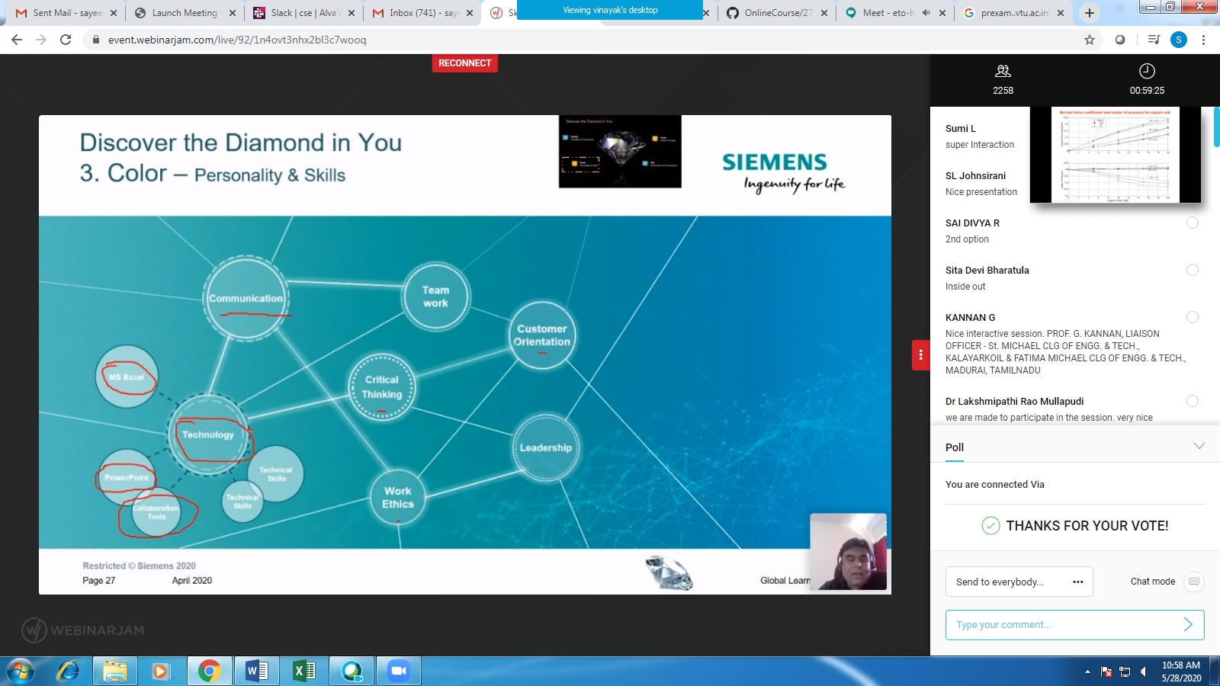

**Attended Faculty Development Program on “Networks & Security “**

**(Morning 11.00 to 1.00)**

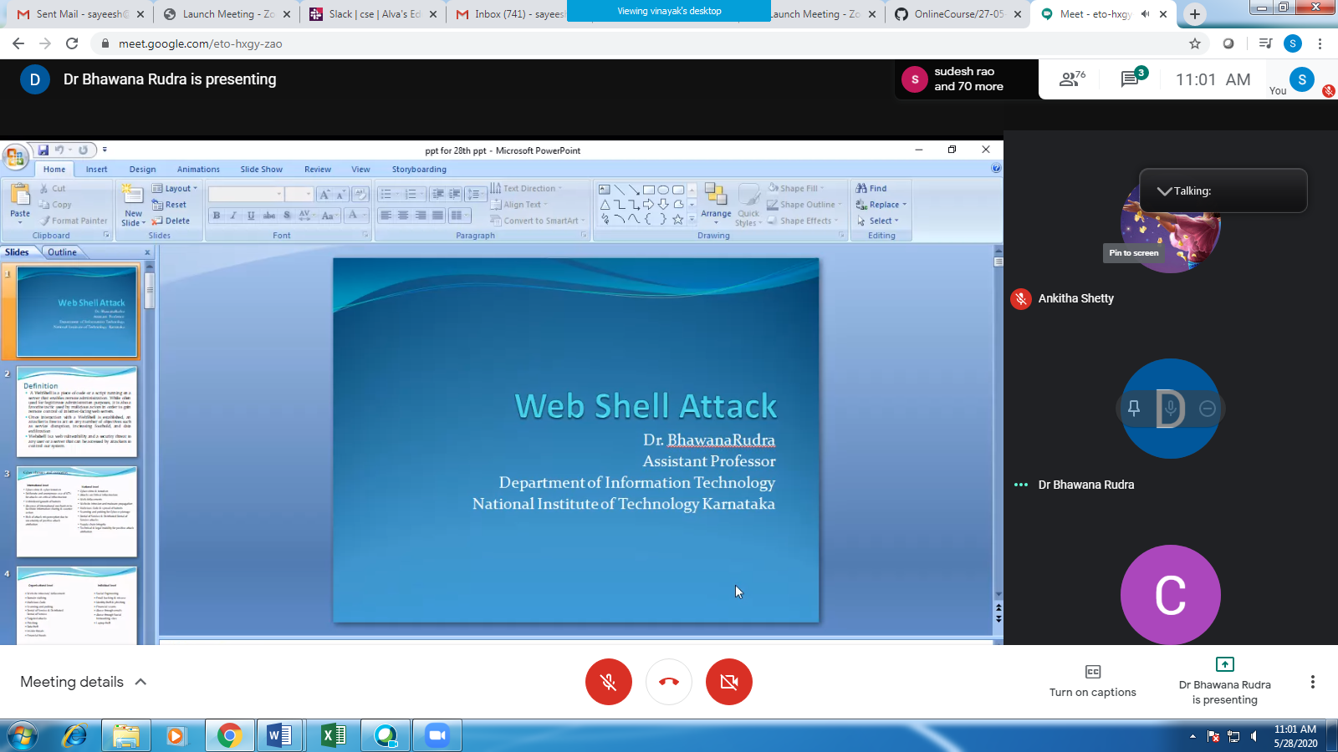

**Attended webinar on “Deep Learning ” (Morning 10-11)**

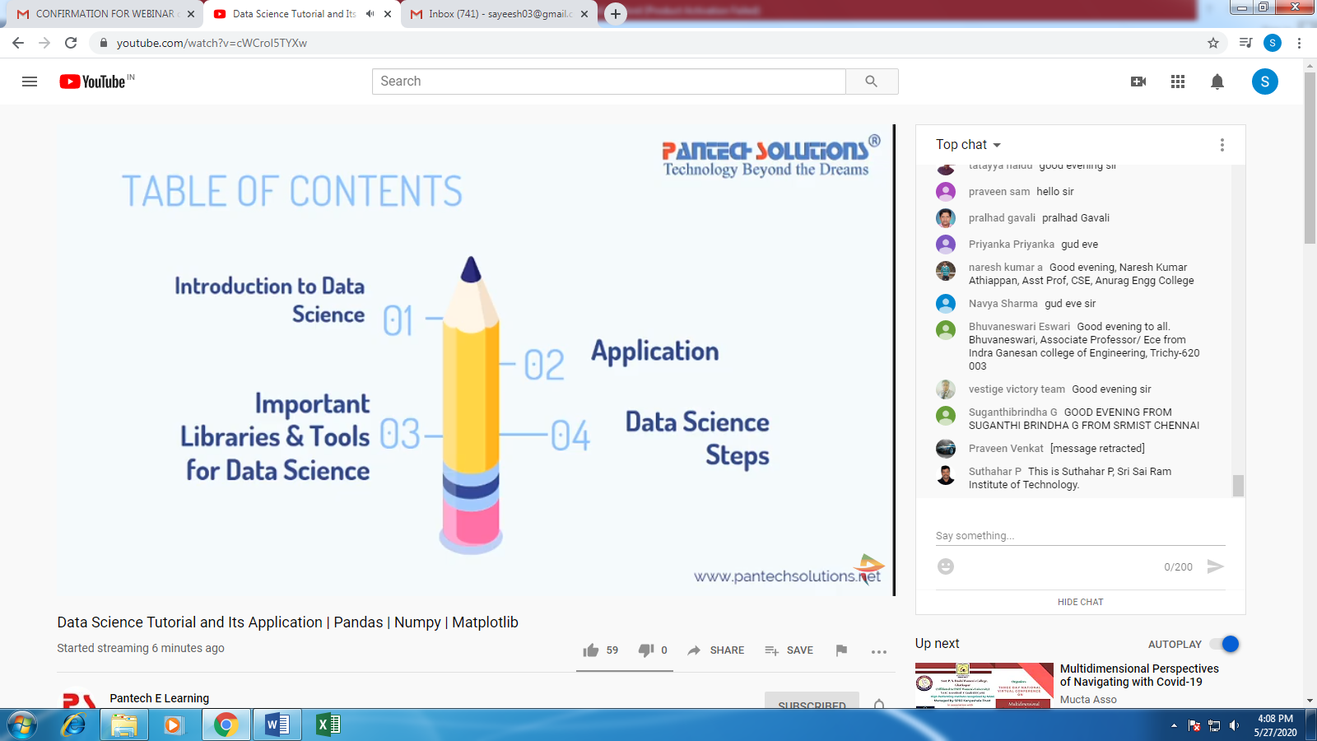

Today’s JSP Explanation:

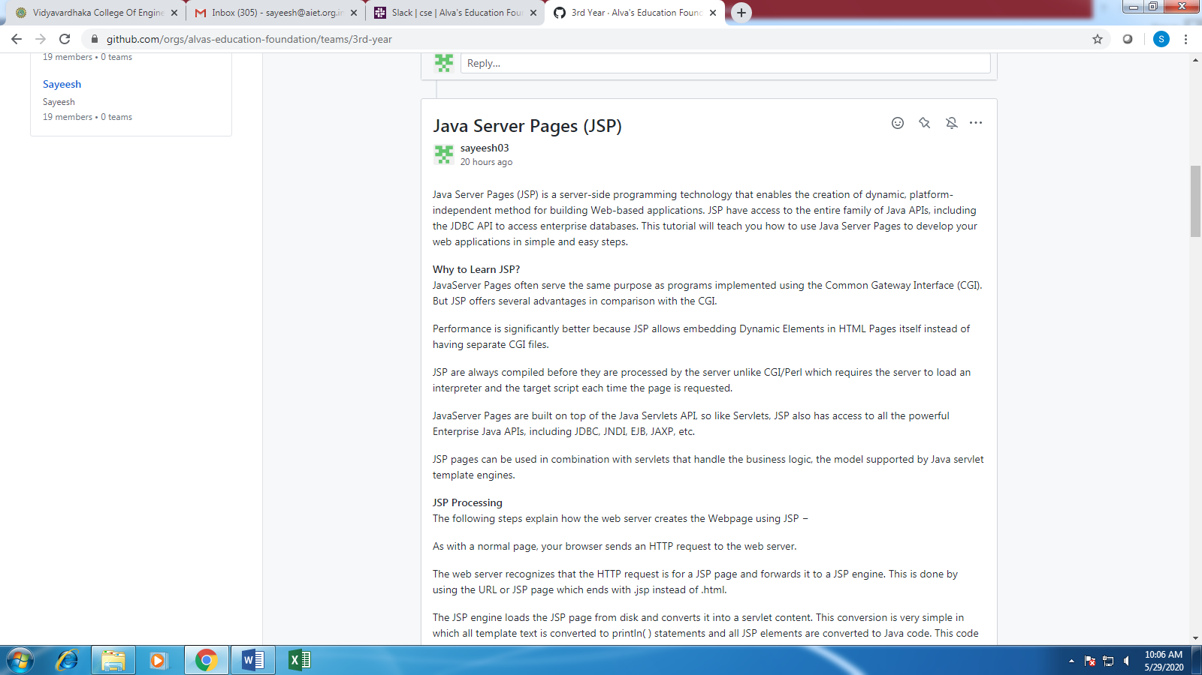

Today’s Java Problem Given:

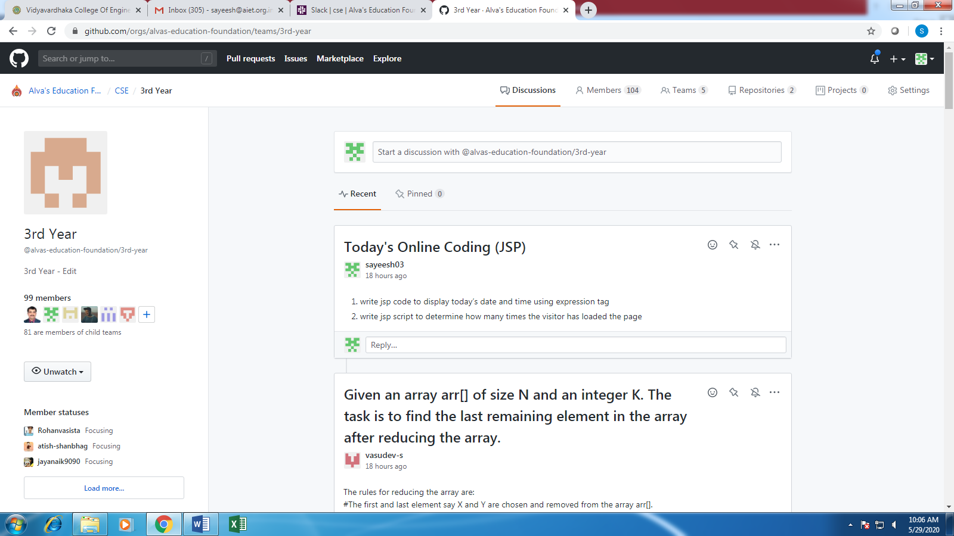

**Students Report:**

